Tamis Parron/Sven Beckert

Rethinking Global Capitalism
Program

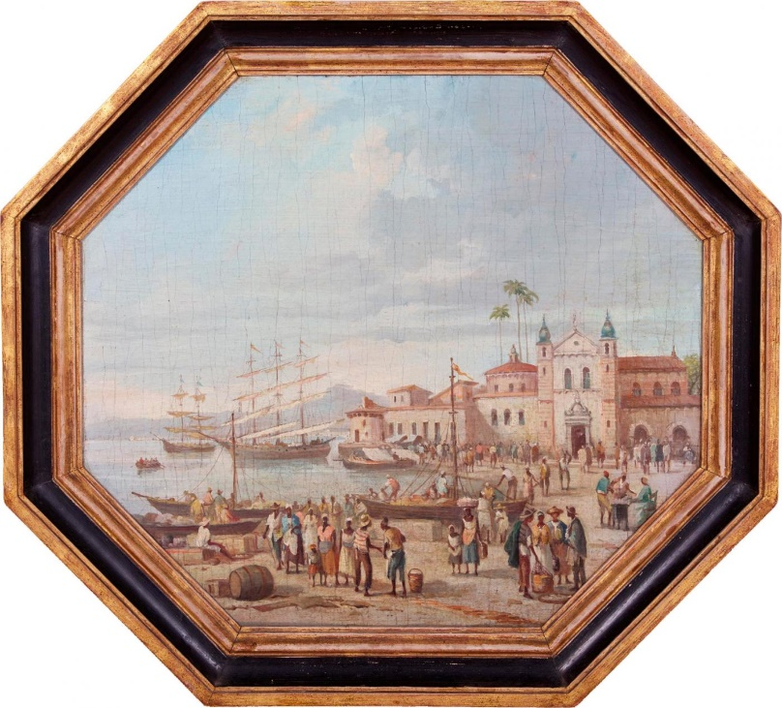

Niterói, Rio de Janeiro, Brazil
March 13-March 15
Universidade Federal Fluminense, Campus Praia Vermelha
(Auditório do Instituto de Computação,
Av. Gal. Milton Tavares, s. n)

Sponsored by
David Rockefeller Center, Harvard University
Fundação de Amparo à Pesquisa do Estado do Rio de Janeiro (FAPERJ)

Organized by
Weatherhead Initiative on Global History, Harvard University
Centro UFF sobre Desigualdades Globais, Universidade Federal Fluminense

With the support of
Unesco Chair on Global and Social Inequalities: Innovative Approaches

Wednesday, March 13

1:00 p.m. Welcome words

Tamis Parron, Federal Fluminense University (UFF)
Sven Beckert, Harvard University
Giselle Venancio, coordinator of the UFF Unesco Chair on Global and Social Inequalities: Innovative Approaches

2:00 p.m. Panel 1: What is New in the New History of Global Capitalism?

Emile Chabal, University of Edinburgh
Transition, Revolution, Modernity: (Re)thinking capitalism with Eric Hobsbawm

Lorenzo Fusaro, Universidad Autónoma Metropolitana (Mexico City)
Rethinking Dependency and the History of Global Capitalism

Kaveh Yazdani, University of Connecticut
The Biography of Capitalism(s): The Second Millennium

Pedro Mattos and Pedro Bastos, State University of Campinas (Unicamp)
Towards a Theory of Structural Dependency

Moderator: Carla Curty, Universidade Federal do Rio de Janeiro (UFRJ)

5:00 p.m. Keynote 1: Thinking Globally from A Local Perspective

John Tutino, Georgetown University
The Revolution that Turned Global Capitalism: Bajío Insurgents, Alternative Capitalisms, U.S. Hegemony, and the Road to Globalization

Thursday, March 14, 2024

9:00 a.m. Panel 2: Planetary and Extraplanetary Connections

Raymond Craib, Cornell University
Distant Archipelagoes, Near Futures, and Global Capitalism

Ashley Bohrer, University of Notre Dame
Colonial Enclosure, Settler Utopias, and the Dark History of Capitalist Commons

Kristin Ciupa, University of Regina
Expanding Extractive Frontiers: Space Mining as Response to Capitalist Crisis

Moderator: Daniel Barreiros, Universidade Federal do Rio de Janeiro (UFRJ)

11:30 a.m. Panel 3: Planetary Labor

Kleoniki Alexoupoulos, Panteion University
Labor Transformations in Colonial and Postcolonial Sub-Saharan Africa
Freg Stokes, Max Planck Institute of Geoanthropology (Jena)
Indigenous South American Labour and Resistance in the History of Capitalism

Shuvatri Dasgupta, University of Cambridge
Empire, Family, and Extractivism: Rethinking Global Capitalism in the Himalayan Foothills

Moderator: Carlos Eduardo Martins, Universidade Federal do Rio de Janeiro (UFRJ)

2 p.m. Lunch

4:00 p.m. Panel 4: Planetary Transformations

Tomas Bartolleti, Swiss Federal Institute of Technology Zürich
Insect Pests and Commodity Frontiers: A Multispecies History of Capitalism

Nicolas Pinsard, University of Lille
Primitive Accumulation and Indentured Servants in France as Drivers of Peripheralization of the French Antilles

Christian Büschges, Melina Teubner and Jean Veloso, Bern University
Towards a Theoretical Agrarian History of Capitalism: Land Grabbing during Global Crises of Capital in Latin America

Moderator: Lise Sedrez, Universidade Federal do Rio de Janeiro (UFRJ)

6:30 p.m. Keynote 2:

Paulo Soethe (UFF/UFPR)
The Magic Mountain: The World Economic Forum in Davos

Friday, March 15, 2024

10:00 a.m. Panel 5: The Local Roots of Global Capitalism

Gladys Ribeiro (UFF) and Marina Galvanese, State University of São Paulo (Unesp)
Enslaved, Sailors, and Migrants: the Nineteenth-Century Rio de Janeiro Waterfront and the Development of Global Capitalism

Martín Rodrigo, Universidad Pompeu Fabra, and Marial Iglesias, Harvard
Trade, Slave Trade and Business in the Atlantic World: Peter Harmony

Manoela Pedroza (UFF) and José Miguel Lana, Universidad Pública de Navarra
Institutional Bricolage, Land Ownership, and Land Markets in a Civil Parish of Rio de Janeiro in the Nineteenth Century.

Moderator: Paulo Henrique Rodrigues Pereira, Universidade de São Paulo (USP)

12:30 p. m. Lunch.

2:30 p.m. Panel 6: Forging Capitalism in the Global South

Ritesh Jaiswal, University of Delhi
The World of Non-European Capital in the Indian Ocean: Examining Chettiar Merchant-Bankers Contribution to Global Capitalism

Salma Abouelhossein, Harvard University
Planning and the Deployment of Bandung

Alexandre Fortes, Universidade Federal Rural do Rio de Janeiro (UFRRJ)
The Second World War and the Rise of Mass Nationalism in Brazil: Class, Race, and
Citizenship

Moderator: Alexandre Barbosa, University of São Paulo (USP)

5. p. m. Keynote 3: Thinking Global Capitalism Globally

Dale Tomich, Binghamton University
Historical Globalizations of Capital: Commodities and Money, Productive Capital, Labor

