Tübingen Science Bridge – October: Edition Artificial Intelligence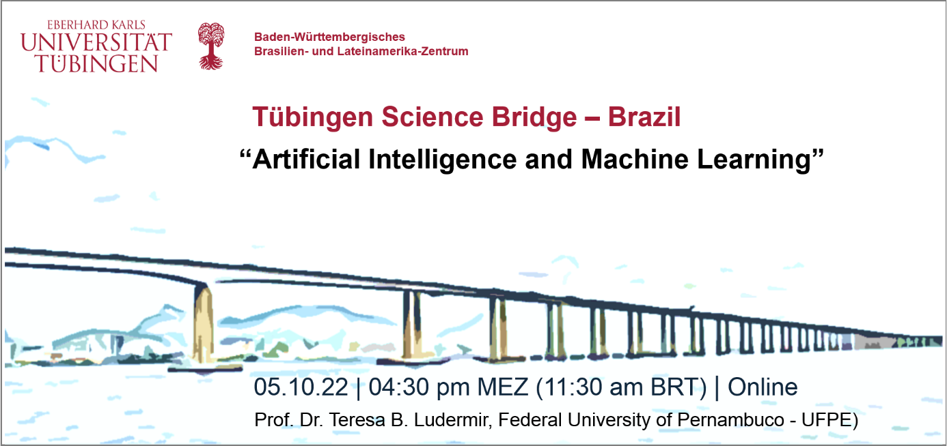
***Deutsche Version unten*** | *** Versão em português abaixo***
The next webinar from the program Tübingen Science Bridge - Connecting Brazil Germany, which takes place on October 5 at 11:30 am BRT (04:30 pm MEZ), will focus on the area of Artificial Intelligence (AI) and has the participation of Prof. Dr. Teresa B. Ludermir, Informatics Center at the Federal University of Pernambuco - UFPE. She will put on the agenda the theme "Artificial Intelligence and Machine Learning".
Baden-Württemberg Center for Brazil and Latin America at the Universität Tübingen (Baden-Württembergisches Brasilien- und Lateinamerika-Zentrum) launched the Program Tübingen Science Bridge - Connecting Brazil Germany, in April 2022, seeking for internationalization of Science and Research and new impulses for cooperation between the University of Tübingen and partner universities in Brazil.
The program's goal is to promote and expand science, in addition intensify research cooperation through a sequence of lectures, online. Scientists from several partner institutions present their latest research data, promoting an integrated and constructive environment for scientific interaction and also contributing global knowledge.
The online lectures of the Tübingen Science Bridge emphasize the importance of current scientific topics in international cooperation and are aimed at professors and scientific researchers, graduate students, as well as a more the general audience.
Webinars will be held in English on the ZOOM platform in order to allow discussion and interaction.
Register link: https://bit.ly/TSBridge-october
Lecture Briefing: Machine Learning has shown extraordinary advances in recent years and is currently used to solve numerous technological and economic problems. AutoML is a subfield of machine learning which aims to automate the training & tuning of machine learning models. In this presentation it will be talked about Machine Learning applications in our daily lives and AutoML.
Short bio: Teresa B. Ludermir received the Ph.D. degree in Neural Networks in 1990 from Imperial College London. She is a Professor and head of the Artificial Intelligence Group at Centro de Informatica, Universidade Federal de Pernambuco, Brazil. She has published over 400 articles in scientific journals and conferences and three books in Neural Networks (in Portuguese). Her research interests include weightless Neural Networks, hybrid neural systems and automated machine learning (AutoML).

*** Versão em português ***
O próximo webinar do programa Tübingen Science Bridge - Connecting Brazil Germany, que acontece no dia 05 de outubro às 11:30 am BRT (04:30 pm MEZ), terá como link a área da Inteligência Artificial e contará com a participação da Prof. Dra. Teresa B. Ludermir, do Centro de Informática da Universidade Federal de Pernambuco - UFPE. Ela colocará em pauta a temática “Artificial Intelligence and Machine Learning".
O Centro Brasileiro e Latino-Americano de Baden-Württemberg da Universidade de Tübingen lançou o programa Tübingen Science Bridge - Connecting Brazil Germany em abril de 2022, com foco na internacionalização da Ciência e Pesquisa e de novos impulsos para a cooperação entre a Universidade de Tübingen e universidades parceiras do Brasil.
Além de aproximar e fortalecer o trabalho colaborativo, por meio de uma sequência de palestras (on-line), a iniciativa tem como objetivo promover e expandir a ciência. Cientistas de diversas instituições parceiras apresentam seus últimos dados de pesquisa, promovendo um ambiente integrado e construtivo da ciência e, ainda, disseminando o conhecimento global.
As palestras on-line do Tübingen Science Bridge são destinadas a professores e pesquisadores científicos, alunos de pós-graduação, como também para o público em geral. Os webinars acontecem em inglês na plataforma ZOOM para permitir a discussão e interação.
Faça sua inscrição aqui: https://bit.ly/TSBridge-october

***Deutsche Version ***
Das nächste Webinar im Rahmen des Programms Tübingen Science Bridge – Connecting Brazil Germany, das am 5. Oktober um 04:30 pm MEZ (11:30 am BRT) stattfindet, befasst sich mit dem Bereich Künstliche Intelligenz und wird von Prof. Dr. Teresa B. Ludermir, Informatics Center at the Federal University of Pernambuco - UFPE gehalten. Das Thema lautet „Artificial Intelligence and Machine Learning”.
Das Baden-Württembergische Brasilien- und Lateinamerika-Zentrum der Universität Tübingen hat dieses neue Programm aufgelegt, um der Zusammenarbeit zwischen der Universität Tübingen und ihren Partneruniversitäten in Brasilien neue Impulse zu geben. Das Programm Tübingen Science Bridge – Connecting Brazil Germany, das einen Beitrag zur Internationalisierung von Wissenschaft und Forschung leistet, wurde im April 2022 gestartet.
In einer Online-Vortragsreihe präsentieren hochkarätige Wissenschaftler:innen der verschiedenen Partnerinstitutionen ihre neuesten Forschungsergebnisse und tragen damit zu einer gemeinsamen und konstruktiven Basis für die wissenschaftliche Zusammenarbeit bei.
Die Online-Vorträge der Tübingen Science Bridge richten sich besonders an Hochschullehrer:innen und (Nachwuchs-)Wissenschaftler:innen, sowie an ein allgemeines wissenschaftlich interessiertes Publikum.

Die Veranstaltungen finden auf Englisch über die Plattform ZOOM statt, um eine Diskussion und Interaktion zu ermöglichen.

Registrieren Sie sich hier: https://bit.ly/TSBridge-october

